**Avalanche Weather Page Common Framework Setup**

**Web page**

Log into CMS. Create a page called AvalancheWeather like the example below:

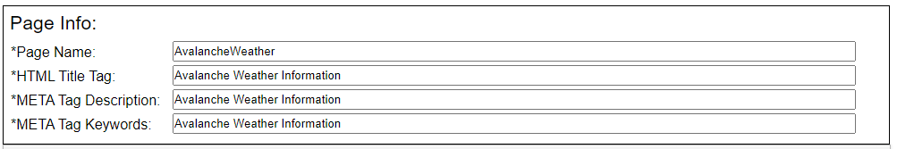

Copy and paste all code from the attached AvalancheWeather text document. The only think you will need to do here is change the CWA variable **SLC** to your office identifier. Save and exit the CMS Editor.

**Site Configuration**

If you are using AVG points, download the following file:

<https://www.weather.gov/source/slc/avalanche/siteConfig.json>

If you are using AVG edit areas, download the following file:

<https://www.weather.gov/source/afg/avalanche/siteConfig.json> (Not online yet).

Edit either file using the following as considerations:

**Mapping example (common to GridPoint based and EditArea based):**

{"wfo": "SLC", **< Change to your office identifier**

"MAPPING":{

"centerLat":39.41, **< Center latitude of your CWA (for the map)**

"centerLon":-111.95, **< Center Longitude of your CWA (for the map)**

"mapZoom":6 **< Zoom level to get the best view of your CWA (for the map)**

},

"AVG_Sites": [

**GridPoint Example:**

{

"location":"Nordic Valley", **< Name of AVG Point (for display purposes)** *

"geometry": {

"type": "GridPoint", < This will be GridPoint or ShapeFile

"coordinates": [ -111.88,41.31 ] < If GridPoint, lon/lat of point **

}

},

**Edit area ShapeFile example:**

{

"location":"Eastern Alaska", **< Name of AVG Point (for display purposes)**

"geometry": {

"type": "ShapeFile",

"coordinates": "Eastern_AK_Range_EditArea.json" < GEOJSON file name ***

}

},

* The location needs to match the name of the AVG location, minus anything in parentheses

** The coordinates is where the marker icon will be positioned on the map

*** This should be the AWIPS Edit Area shapefile, converted to GEOJSON. If you need help with this conversion, email all of your shapefiles to [allister.martinelli@noaa.gov](mailto://allister.martinelli@noaa.gov).

**Uploading Site Configuration**

In CMS, make a folder under PublicData called “**avalanche**”

Upload “**siteConfig.json**” to the avalanche folder

Upload any Edit Area shapefiles to the avalanche folder (this can be done later)

Go to https://www.weather.gov/xxx/Avalanche Weather (where xxx is your office identifier).

Refine the *centerlat*, *centerlon* and *zoom* variables at the top of your **siteConfig.json** to make the map look the best for your office.